Game Design Document

Fill up the following document

1. Write the title of your project.

Snake game

1. What is the goal of the game?

Snake has to eat the apple and the score will increase depending on the apple,snake eat

1. Write a brief story of your game.

Snake has to eat the apple and the score will increase depending on the apple,snake eat ,the game will be over when snake will try to go out of game area…

1. Which are the playing characters of this game?

* Playing characters are the ones who respond to the user based on the input from the user.
* Cars, monkeys, dinos, wizards, etc., are the playing characters in the game.

|  |  |  |
| --- | --- | --- |
| Number | Character Name | What can this character do? |
| 1 | snake | Eat the apple |
| 2 | apple | Helps snake to grow its size |
| 3 |  |  |
| 4 |  |  |
| 5 |  |  |
| 6 |  |  |
| 7 |  |  |
| 8 |  |  |

1. Which are the Non-Playing Characters of this game?

* Non-Playing characters are the ones that don't have an action or behavior when the user interacts with the game.
* Hurdles, stones, bananas, coins, etc., are non-playing characters in the game.

|  |  |  |
| --- | --- | --- |
| Number | Character Name | What can this character do? |
| 1 | borders | Kills the snake |
| 2 |  |  |
| 3 |  |  |
| 4 |  |  |
| 5 |  |  |
| 6 |  |  |
| 7 |  |  |
| 8 |  |  |

Draw your imagination of this game. What does this game look like?

* Draw the game either on your computer or on paper.
* Add images of the game scenes to show each of the playing and non-playing characters at least once.

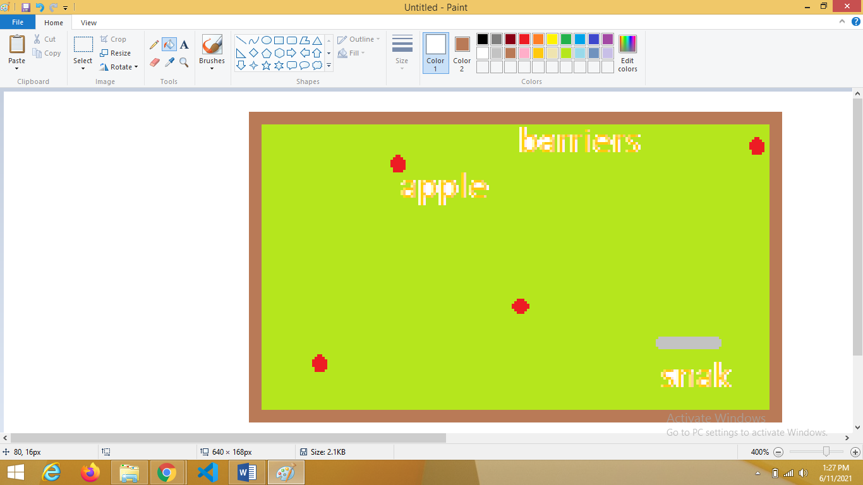

How do you plan to make your game engaging?

The game will not be so tough ,we will be adding sounds whenever the player will get the score